**File Creation Task**

1. ***Create a directory called ""my_folder"", navigate into it, and create a file named ""my_file.txt"" with some text. Then, create another file named ""another_file.txt"" with some text. Concatenate the content of ""another_file.txt"" to ""my_file.txt"" and display the updated content. Finally, list all files and directories in the current directory.***

**Explanation:**

1. Created the directory called my_folder using **mkdir** and using **cd**, entered inside the created folder (my_folder).
2. Created the new file in my_folder named “my_file.txt” using **vi** and entered “command line interface” inside that file by pressing **i (insert mode)**. Post which clicked **esc** and used **:wq** to save the content of the file.
3. Same process followed as B and created another file “another_file.txt” and given “Graphical user interface” inside that file. Used **cat** to display the contents of the created files.
4. To concat the content of another_file.txt to my_file.txt, **cat another_file.txt >> cat my_file.txt** command is used. Now all the content in the another_file.txt merged with content in the my_file .txt. **cat my_file.txt** will display the content of my_file.txt which shows the content concatenated from another_file.txt.
5. To list all files and directories in the current directory, **ls** is used.

Output:

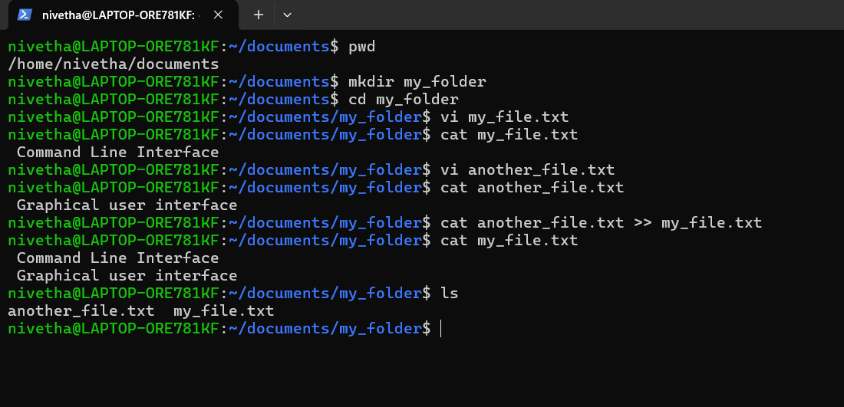

***2. Create 20 files with .txt extensions and rename the first 5 files to .yml extension and Print the latest created top 5 files among the total no of files".***

**Explanation:**

* 1. To create the 20 files with .txt extensions, **touch file{01..20}.txt** is used. Used ls to check the created files.
  2. To rename the first 5 files to yml extension,

**for i in {1..5}; do mv “file$i.txt” “file$i.yml”; done.**

The above command is a “for do” loop that identified the first 5 files, then uses the $i variable to implement successive mv commands that rename the files from 1 to 5 from .txt to .yml extension.

Used ls to verify the renamed files.

* 1. To print the latest created top 5 files among the total no of files,

**ls -lt | head -n 6** command is used.

ls -lt lists files sorted by modification time in descending order.

head -n 5 shows the top 5 entries from the list. -n 6 is used to ignore the total in the top.

Output:

